Chapter 7
How to Eat Right and
Have the Body Beautiful

Diet
If you wish to grow thinner, diminish your dinner,
And take to light claret instead of pale ale;
Look down with an utter contempt upon butter,
And never touch bread till it’s toasted – or stale.
H.S. Leigh (1837-83), English author. A Day for Wishing.

How to Get 20 More Years of Good Life

Living the Bad Life

Our way of life is killing us. Ripping off 20 good years.

On the one hand, we have one of the highest standards of living in the world.

On the other hand, we also have one of the lowest standards of living in the world.

On the one hand, our average life span goes up. On the other hand, your chances of living another 10 or 20 or 30 or 40 years do not.

On the one hand, the average life span of a white male baby was 50 years in 1900 and 67 years in 1970. Our modern medicine has pretty much wiped out death from infectious diseases and deaths during infancy and childhood. On the other hand, your chances of getting wiped out by one of our popular degenerative diseases is higher than in most third world countries.

On the one hand, since 1920, our death rate due to infectious disease for 35 to 44 year olds has dropped from 250 to less than 5 per 100,000. But on the other hand, the average life span of a Bolivian 40-year-old is 73 years, while for a white American male 40-year-old, it’s only 71 years, 5 months. And the average life span of a white male 50-year-old was 72.25 in 1920, and had only risen to 73 by 1970.

As of 1999, here’s the latest update: “The average life expectancy for Americans is around 75 years, almost twice what it was in the early 1900s. Although some people never reach this age, and others are beset with illnesses if they do, more and more people are living healthy lives well into their 90s and older.”

So once you get past childhood, you’re worse off in the United States than most places in the world, in spite of all the help you can get from our impressive medical technology. And one of the main culprits is your diet. Your diet causes you to be overweight, if not obese, and it causes you to lose years of your life because of degenerative diseases. It gives you extra pounds and steals from you several good years of life—a poor swap. We’ve already talked about sugar, but there are several other culprits that rob years from you.
Why Our Diet is Hurting Us
We consume too many harmful foods that conatin animal fat, unsaturated vegetable fat, and salt. Eating too much animal fat can lead to heart attacks, arthritis, diabetes, and osteoporosis. ,Excess unsaturated vegetable fat can cause atherosclerosis, play a role in causing cancer, and speed up the aging process. Eating excess salt contributes to hypertension; arthritis; poor vision, hearing, and touch; and stiffness of the muscles and joints. (For more details, visit http://dickmalott.com.
Some biblical scholars have concluded that the serpent tempted Eve, not with a healthy apple but with a Big Mac, fries, and a shake.
The Good News
That’s the bad news. The good news is that you can pretty much prevent these problems or pretty much get rid of most of them if you’ve already got ‘em, by cutting way back on your fat and cholesterol, as well as wiping out processed sugar, and by increasing your fiber.

The Bikini Factor

But who are we trying to kid with all this health and humanity nonsense. We know what the real bottom line is, don’t we? It ain’t got nothin’ to do with how long you live. The bottom line is your bottom—the bikini factor. How well you’re gonna’ look in that bikini this summer. Vanity. All else is rationalization. Fortunately a healthy diet will put you in that teeny weenie little bikini this summer as well as give you a longer bikini-wearing life.


What You Weigh Is What You Eat (and What You Do)

You want to lose weight? Then you’ve got to eat less. I go for the 2-pounds/week weight-loss diet, because I figure with all the slop in my measuring and self-management systems, that way I’ll at least have a chance of losing 1 pound per week.

But you must keep in mind that the less you weigh, the less you can eat and still lose weight, ‘cause you aren’t carrying around as much calorie-burning meat.
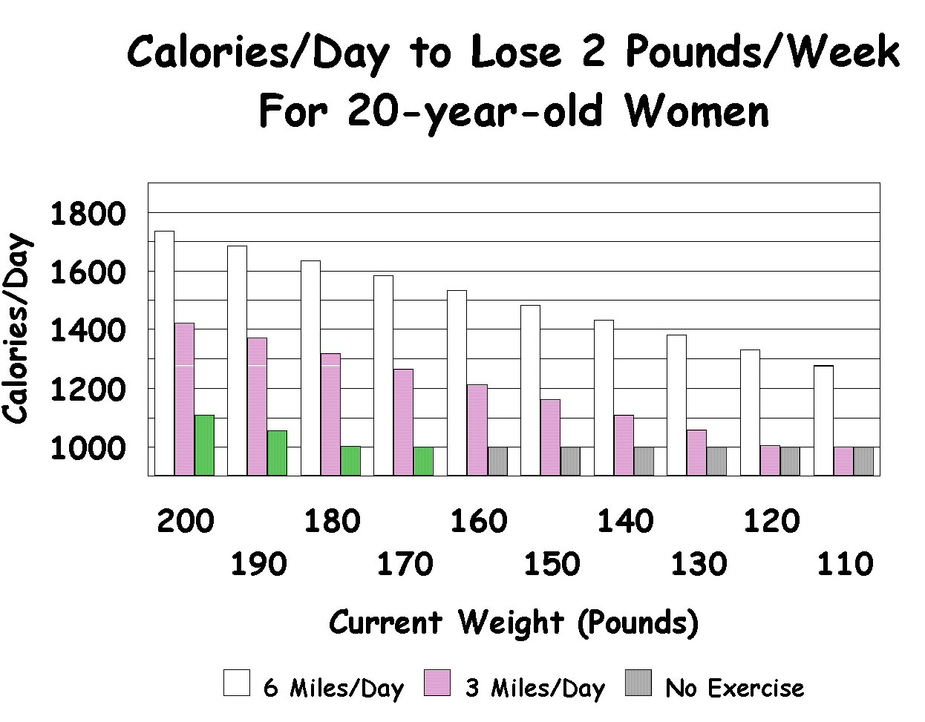

Yeah, I know, men can eat more calories and still lose weight. Yes, it’s a cruel unfair world. In fact, a 200-pound woman had to spot a 200-pound man about 500 calories.
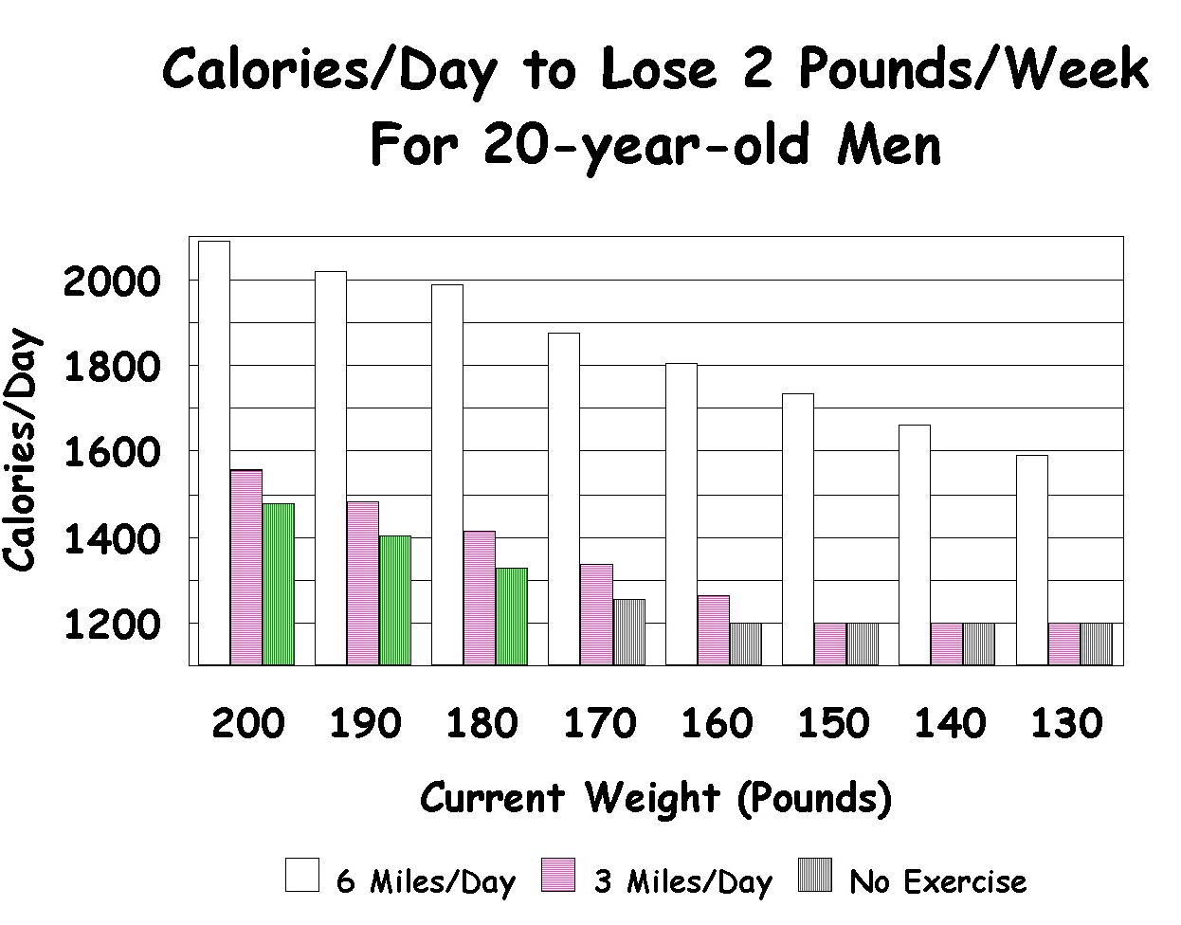

These two graphs also show that the more you exercise, the more you can eat and still lose weight. Running (or walking, it’s about the same) 3 miles buys you a few extra calories of eating per day, but running 6 miles can buy you 600 extra calories, if you’re carrying enough weight on your bones, while you’re doing those 6 miles.

Yes, it really is an unfair world when you note that an 80-year-old male 200 pounder also has to spot a 20-year old-male 200 pounder 500 calories. Those 20-year-old males have it all going for them, don’t they.

By the way, the American Dietetic Association says to keep your daily calorie intake above 1500 calories. So, if you’re not losing enough pounds on 1,500 calories per day, then you’ll need to log in some stair-master time.
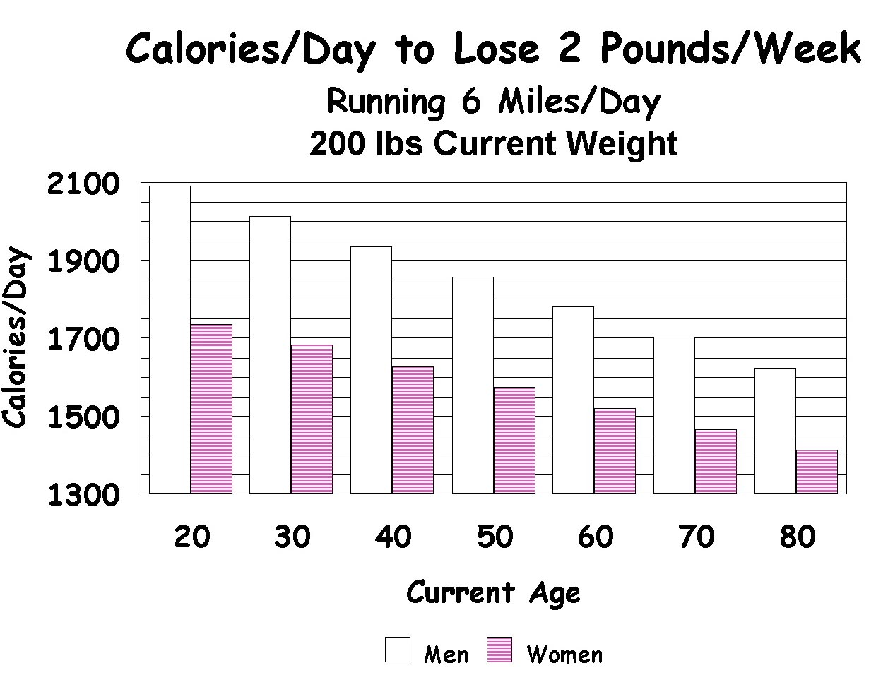

The Genetic Cop Out

Don’t blame me; it’s in my genes. See, I’ve got this genetic predisposition to obesity, really.

Sure you do. Sure you’ve got a genetic predisposition to hot fudge sundaes with real whipped cream. O.K., we all do.

No, really. It’s worse for me than it is for you.

Awwwwww, tsk, tsk. Then check this out before you drown your whines in another of them deliriously delicious ice-cream delights:
Rats bred for thinness can still get fat on a diet of snack foods; animals genetically prone to be fat will get fatter on the same diet. But both groups lose weight if returned to a normal maintenance diet. Furthermore, even fat-prone rats can be saved from obesity if their physical activity is increased.

Sorry, there just ain’t no place to hide. We accept no excuses here.
The National Center for Health Statistics finds that 35% of U.S. adults are overweight enough to be unhealthy, an increase of 15% since 1980. It notes that 36% of women, 33% of men, 14% of children aged 6–11, and 12% of adolescents aged 12–17 are obese. March 6, 1997

The Self-Management Approach to Healthy Eating

My first efforts at all around healthy eating came several years ago because of reading Michael Jacobson’s Nutrition Scoreboard. I got a beautiful four-color poster from Jacobson’s Center for Science in the Public Interest. The poster had the various foods listed according to their nutritional value, with points assigned to each food. And you were supposed to get somewhere between 600 and 1000 points a day. I mounted the poster on our refrigerator door and very conscientiously followed its rules for several days. But my nutritious diet became dog-eared long before the poster itself did. (Posters, signs, and bulletin boards may be the most ineffective means of controlling human behavior that mankind has invented.) Then for Christmas, 1977, a friend gave me a copy of Live Longer Now by Leonard, Hofer, and Pritikin. The book impressed me so much that I started on its recommended diet on New Years Day, 1978, and have been more or less on it ever since. The book is about the best popular exposition of scientific data I’ve ever read; in fact, much of the information in these chapters comes from that book, as well as The Pritikin Program for Diet and Exercise by Pritikin and McGrady. They are my bibles.

The first book contains a scoring system, which helped a lot. A perfect meal contained no extra sugar, fat, or cholesterol other than what would be in ¼ pound of lean meat per day.

I used a year-at-a-glance graph to record the number of perfect Live-Longer-Now (LLN) or Pritikin meals, and it worked amazingly well. I no longer have my 1978 graph; but for 1979, I was 92% perfect.

And during 1980 I was 99.93% perfect. My violations were four dinners and one snack, all of which I had at various occasions while eating out of town. By this time in 1981, I found it so easy to stick to the Pritikin diet, that I stopped graphing and only had one impure meal. That one was out of town. And I probably hung in with that one little element of sin for a few years. For the next three years, after the Detroit Free Press International Marathon, we would stop for a dinner at a vegetarian restaurant in Ann Arbor. A small, Non-Pritikin indulgence.

I also should mention that this project didn’t require any behavioral contract or penalties. But I wouldn’t have hesitated to use them if I’d needed to. I also should remind you that I did have a separate graph for sugar like the one we talked about in the last chapter.

The Pritikin Diet

The Pritikin diet is more or less as follows:
- 80% complex carbohydrates (starch, like in potatoes, bread, and pasta, not simple sugars like in candy, cake, honey, or molasses)
- 10% protein
- 10% fat


Update

As of the beginning of the new millennium, I’d been on the Pritikin diet for 22 years, sticking pretty close to it, when I eat at home, but a little looser when I’m on the road. I like it and am happy with it. It works and I don’t find it too hard to stick to, except for some special devil’s temptations I’ll address later.
The second day of a diet is always easier than the first. By the second day you’re off it. — Jackie Gleason

Extra Graphs for Extra Heavy-duty Problems

By the way, you may recall that in 1978, I stopped graphing my sugar junk food eating prematurely and found that I lost some control over that vice. One reason I did that was that I thought my LLN scoring system would carry the burden. In other words, a violation of the sweets restriction would cost me points on my LLN graph. And true enough, I rarely lost points because of my sweets. But here’s what did happen. If I lost points because I had eaten salt, or fat, or too much fat or cholesterol, or too much meat, then I’d already blown it; and I couldn’t lose any more points if I ate an extra dessert, . . . or two, . . . or three. Amazing, isn’t it, how the means become so much more important to us than the ends. The points were of no real value, but my health was. Yet it was the points that were controlling my behavior. A little symbolic nothing, the points are so much more effective than the real thing, a healthy life, if the symbol is sizable and probable, and the real thing is in the small, though of great cumulative significance, or if it is not probable. And knowing this fundamental fact about the nature of all organisms, including the human ones, normally helps us to manage our lives with some degree of success. But once in a while, we don’t get it all thought through. In any event, if you have a special problem, like I had with sugar, you might have to deal with that by using a separate graph.

Get Thee Behind Me Satan

Needless to say, he said needlessly, you should use the get-thee-behind-me-Satan technique with this diet. Throw out or give away all foods that have sugar, salt, or oil in them. And that probably means almost everything you have in your kitchen, pantry, and freezer. Be like Jesus cleaning out the temple of the money lenders. Sugar, salt, and oil are defiling the sanctity of your home and body.

If you can’t bring yourself to do anything so drastic, then at least don’t bring any more of that crap into your home. And see how it goes. If you find yourself backsliding, then maybe you will have to do something drastic, and get rid of it all. Or at least, box it all up and stash it away in your attic, until you know you really are committed to this new diet. Now here’s a little concession I do make for company. I have a little sugar and a little salt hidden on my top shelf. And I may buy an occasional stick of margarine for them. But if I found they were pulling me off the wagon, I’d throw them out in an instant.

Hedonistic Stoicism

No sugar, no salt, no fat, no cholesterol. No fun? No, we have fun galore!

I suppose what I missed most was the salt. I had the hardest time avoiding extra sugar. But as far as the taste of the food itself was concerned, I missed the salt the most, in spite of all the extra spices we put on the food. Somehow, there just seemed a hollowness underneath all those spices that just couldn’t be filled by anything but salt. Yet I was never tempted to add extra salt. But then

again, I never used the salt shaker that much anyhow.

But after about six months, my taste receptors (I guess) recovered from the heavy salt burnout they’d been subjected to for the previous 40 some years, and the natural flavors of food took over. I no longer missed salt. In fact, when I’ve accidentally eaten rye bread with salt in it, I’ve found it pretty aversive, though at other times salty foods haven’t bothered me. Generally, the people I’ve talked to who’ve spent some time on a salt-free diet don’t seem to miss it.

Actually, I’m much more into food and have much more fun with my food than ever before. For one thing, food no longer seems like a frivolous self-indulgence. Food is now a serious part of my life. Second, food has become a fascinating hobby—trying to make it nutritious, harmless, and delicious—a task that becomes easier and easier as our pallets become less jaded by crap foods we’ve been eating. I now find food and food preparation an interesting topic of conversation—much more interesting than what restaurant serves the steaks with the most fat marbles throughout them.

As far as company’s concerned, that’s not been much of a problem. Perhaps partially due to my social insensitivity; but I always try to put my best Pritikin foot forward, by serving food they’ll most likely enjoy. And the food usually seems to taste better to them than they had anticipated, though perhaps not quite as good as they indicate. But the salt shaker’s on the table just in case. And again, the meal and the diet, and the way of life always become a topic of conversation. Not bad. In fact, many people get turned on to the diet this way. And what can be more reinforcing than successful proselytizing. Of course, a few get turned off this way also. Eating out usually causes no problems either. Just order a big salad with no eggs, meat, bread, or cheese—just pure veggies, a couple of lemons to squeeze on the top for dressing, and a couple plain baked potatoes on the side. Works fine.


I’ll admit that when I first got into this scene, I used to be even more ostentatious, bringing a pint jar of my own salad dressing and sometimes even my own Pritikin bread. But I’ve mellowed with age.

The real trip is when you go on the road for a few days. Now it used to be the continuous pig-out was a major part of going out of town for a vacation or to a convention (for a vacation?). Like when my buddy Don Whaley and I’d get together for a few days, it would be nonstop pig-out city. And then the guilt and extra weight, etc. But no more. The last time we spent a few days together in Dallas, we brought our pots and pans, a hot plate, an ice chest, and some vitals. We ate Pritikin the whole time, felt self-righteous as hell, and had a ball.

Another item we had was a hot-air popcorn popper, which allowed us to pop a batch of greaseless corn, (with no salt of course). Then we put it in a plastic bag to eliminate the paper rustle, stuffed the bag in my big brief case, and snuck it into the movie theaters. Living on the outskirts of the law like that adds more than enough additional spice to make up for the missing salt and grease. Now I rarely go to a flick without my brief case. (Unfortunately, as of July, 1996, the local flickery has gotten hip; they now have their own hot-air popper, making it hard for me to rationalize my outlaw life style. Of course their hot-air hipness may save lives.)

For a few years, when I went to our annual professional convention, for the Association for Behavior Analysis, I also trucked along all my cooking paraphernalia. Then I had many of my meals in my room, occasionally turning colleagues on to the joys of inexpensive, healthful convention eating; and fixin’ your own can save mucho bucks when you’re stayin’ at one of those big-time hotels. I felt a little like Fidel Castro who was alleged to have brought live chickens into his rooms in the hotel the last time he visited New York City. Presumably they slaughtered them, plucked them, and ate them. It is fun to be outrageous once in a while. But after a few years, I came to conclude that I was spending too much of my precious convention time in my room cooking and not enough time participating in the convention; so I quietly slipped back into the hotel dining rooms. So again hedonistic stoicism wins out. You do have to give up a few things, and there are a few hassles, but it sure is fun.

By the way, the less meat and processed food you eat, and the more whole grains and dried legumes (beans and peas) you eat, the more $ you save. More $ and more health.
BETTER TO HAVE LOST AND GAINED THAN NEVER TO HAVE LOST AT ALL.

E-mail from a friend: Things are kind of slow for me. Exercise is sporadic, but not dead. I lost 9 pounds, but have gained most of them back. C’est la vie....

Uncle Dickie: Sometimes you have to lose a few pounds for a while, just to maintain the status quo (which still puts you ahead of most people) ‘cause otherwise you’d just have gained the extra weight with nothing to fall back on. In other words, better to have lost and gained than never to have lost at all.

Confessions of a Sugar Addict

I may have sunk to my lowest depths of degradation the night I ate ten desserts. It was a potluck some of my students were putting on. All sorts of goodies covered the table. So of course, I had to sample each, sometimes repeatedly. And I was the life of the party. “See how many desserts Dr. Malott can eat! What a he-man!”

Or there was the time I risked my job at WMU by earning the near-permanent enmity of our department chairman’s wife. I ate all the candy from their kids’ Easter baskets before the kids got a chance at them. I didn’t mean to; we were just sitting there at the kitchen table chatting on Easter Eve, after the kids had gone to bed. The wife casually placed the candy-filled baskets on the table. When I left, the candy had just as casually disappeared from those baskets. The dyed eggs and cellophane grass remained however.


Whenever I visited homes with children they always ran to hide their cookies and candy screaming, “Here comes the cookie monster.” All in good fun, but all serious too. You may get some feel for the nature of my addiction to sugar if I tell you the little buggers were rarely able to hide their precious sweets from me. Within a few minutes, I would search and destroy.

A Toll House cookie is better than nookie.—The Chenille Sisters

But that’s not all. Whenever friends invited me to dinner, I had to eat at least two or three of their desserts to avoid hurting their feelings. Such was my reputation as a discriminating consumer of the various ways of packaging sucrose. And as I was always the obliging guest, my hosts usually had the pleasure of seeing me pig down great quantities of that sweet reinforcer. For instance, I may have helped one of my friends approach the highlight of her career as a hostess. She served her most famous dessert, the floating island — an egg white-based island floating in a green sea of viscous tapioca-like fluid all laced with cups of sugar. After I had eaten three servings, she caught me in the kitchen. I had just wiped out the two remaining islands and was in the act of slurping down the last of the ocean of tapioca, using a huge spoon from her crystal serving bowl. My beard was flecked with the green froth, like the jolly green giant of the world of desserts, a modern Henry VIII.

Early solutions

Now for years I had been aware of the bad effects of almost all common desserts — they have too many calories, no nutritional value (even a negative nutritional value), and they are bad for your teeth. So because of that, I made many attempts to use performance management to stop eating desserts — candy, ice cream, pie, cake, etc.

My efforts often have taken the form of contracts with built-in fines whenever I would eat a dessert. Sometimes I have made those contracts on the spot, when I found myself in the land of sweets, I would say to someone, “I’ll give you a dollar if I eat any of that junk food.” If children were around, I would usually make the contract with them; and of course, the first thing they would do would be to try to get me to eat some junk food. Then I would say the contract was canceled if they led me astray. At other times I’ve had standing contracts, relying on self-monitoring, where I would agree with a given person — often my secretary — that I would pay them a dollar if I ever ate any junk food.
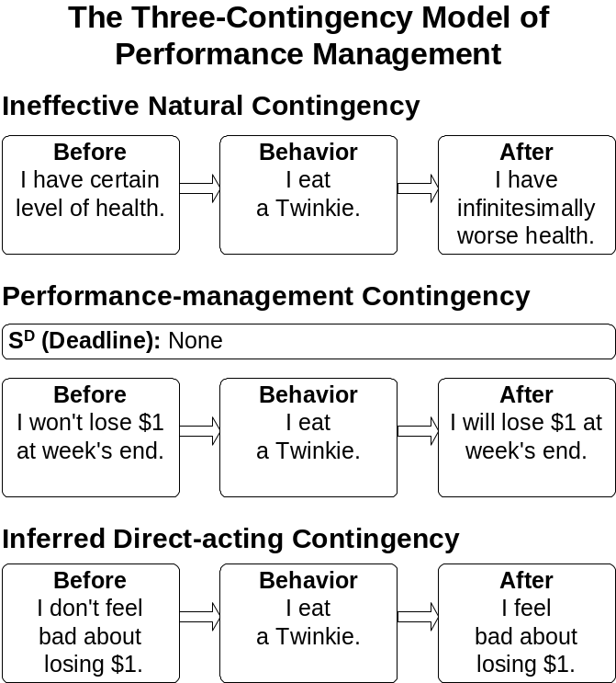

These procedures were somewhat successful for some time, but none were ever totally successful for any extended time. Those self-management procedures would work for a while, and then they’d crack a little bit around the edges (usually on weekends, or on a hot summer’s night when driving by a Dairy Queen), and eventually they’d drop out all together. Then a little later, I’d give it another shot. Finally, either the circumstances were right, or I hit on a self-management procedure that was right, or something, ‘cause it worked.

I still can’t get over the idea that the original cookie monster can now be happy on one piece of fruit a day, happier with three or four, true, but still. . . . I’m not sure I could have gone cold turkey from taking sugar almost intravenously to the bare minimum of one piece a day. It may be I would have relapsed more if I hadn’t first moved over to simply eating too much fruit and juice and then cut it down to three pieces a day etc. Don’t know.


Sugar

You might wonder why I’m making such a fuss about sugar. The answer is that readily-available refined sugar is probably the worst invention the food industry has come up with. With its sweet apple, the snake may have destroyed much of the good life for Adam and Eve; but with their refined sugar, modern food manufacturers and the home cook are now wiping out much of what was left of that good life for the descendants of Adam and Eve.
Sugar has only empty calories.
Sugar raises the levels of tryglicerides (fats) and cholesterol in your blood.
Sugar is related to diabetes.

Sugar, not love, is what can really break your heart.

The solution

The real solution for me was that year-at-a-glance graph we looked at before. There were 52 vertical lines, one for each week in the year, and 7 horizontal lines, one for each day in the week. I’d make a mark for each day I had resisted the temptations of the sweets.

Surprise. At the end of the first week, I had had seven days in a row with no sweets! A perfect week! I drew my bar down through those seven points, proud as if I’d invented electricity. One perfect week, maybe I could make it two. And I did! Two in a row! Well, I sure as hell was not going to blow it, now that I’d gotten a real roll going. And the more hit weeks I had, the more aversive it was to think about blowing it for one lousy dessert, or even several. So I just kept going on and on, determined. Within a few weeks, I had probably been freer of sucrose (table sugar) than ever before in my life.

During spring break, I took a week’s vacation out of town. I decided in advance it would be all right to eat sweets then, because I got back on the program as soon as I returned home. So during that week, it was pig-out city — ice cream, candy, doughnuts, and even flaming desserts. But when I returned home, my graph grabbed a hold of my behavior and I started knocking off those perfect weeks again.

Now the whole thing was a little risky, but I think I did the right thing. The big risk was that I had a week on my graph with all losses. I’d broken up the roll I had going. On the other hand, I undoubtedly would have blown it off by the second day of my vacation anyway. And I would have said I had lost it. And I might have been less likely to get it going, when I got back home. I would have already been a sinner, so why not just keep right on sinning. The way I did it, with dispensation, and absolution beforehand, I was not a sinner and could continue to avoid being one, if I abstained from sweets on my return to Kalamazoo.

No matter how you play it, leaving home is risky business. Things fall apart when you go out of town. You know you’ve really got it wired when you can take your self-management act on the road and keep it together.

The other point is that it really is legitimate to make exceptions to your self-management program. But you must do it in advance, before you get into the situation. It’s O.K. to make rational, well thought out exceptions, but it’s not O.K. to look at a beautiful dessert and then say, “Well, I’ve just decided to make an exception.” As you can see, the exception would soon become the rule. Your decision is more likely to be based on the long range outcomes of your behavior, if you don’t make it in the heat of the action, surrounded by all those sizable and probable reinforcers that are so effective in leading you astray. It’s the difference between a rational decision and rationalization. Of course, if you find yourself making too many of those rational exceptions, then you may want to reconsider this tricky advice.

But back to the sweet tooth saga. It wasn’t all easy going. The monster still lurked deep within my behavioral history. And sometimes I’d fall off the wagon, especially on weekends, and when I tried to stick to my contract while on the road.

Here’s an example of the sort of devils I was fighting. On the road for the whole summer. First temporary stop—Sedona, Arizona, home of the world’s greatest ice cream parlor and candy store. So I rationally decided in advance that I could do a few sweets while passing through that town. Fine, no problem, except that we ended up camping out there for six weeks! And after a couple days, I had degenerated to the point of no return. My beard was constantly filled with caramel, fudge, and marshmallow sauce. The main culprit was the turtle—those three sauces on top of vanilla ice cream and bananas with a few pecans tossed around the periphery, oh yes, and maybe a little malt sprinkled on top. Followed by a half-pound of candy for the road. And nearly every day. But interestingly enough, as I drove across the state line from Arizona into New Mexico, I threw the remnants of the Sedona candy debauchery out the window. On the wagon again.

Now all this took place in 1977. And my abstinence went well enough during that fall that I decided I didn’t need my year-at-a-glance chart anymore. The year of 1978 proved me hasty. I made too many rational decisions to blow off my diet, especially whenever I went out of town. The devils were also really hard to fight in the late evening, when I was carousing about town and running out of steam—maybe a little carbohydrate deprivation? If I happened to drive by a late night grocery, the odds were pretty high I’d go in for a box of cookies.

So, when 1979 rolled around, I got out another sheet of year-at-a-glance graph paper. And 1979 turned out to be my best year to that date. Only four exceptions—two special occasions in Kalamazoo and two out of town. But I’ll admit those four exceptions were real binges.

Here’s a typical one: A few days in New York City, the Big Candy Apple. During my stay there, I became increasingly aware of sugar and speculated covertly about giving in. But I was cool. However, if I did give in, it would have to be for something really terrific, not just a Tootsie Roll.

Sunday afternoon. Let’s take a walk through Greenwich Village. I wonder if that fantastic little pastry shop on 8th street is open today? Curious, you know; that’s all. Damn, it’s closed. Just as well, ‘cause I might have given in. But I’m cool.

The next night, out to dinner with my friends, Hank and Max. I’m cool; no dessert. Walking up Amsterdam Ave., past a sleazy little deli. I wonder out loud whether I should cop some sugar there. Hank says, “No man, there’s nothing in there worth blowing your diet for.” I’m cool; we keep on walkin’ .

One A.M., same night, in a taxi cruising down Broadway toward 42nd Street. My face plastered against the window in a vain search for sugar. Absolutely nothing happening! What a hick town; they roll up the side walks at midnight. Even in the bright lights of Times Square, Howard Johnson’s is the only sugar dispensary open. You mean I’ve come all the way from Kalamazoo to New York City, just to have a sugar orgy in an all-night Howard Johnson’s?

There I sit amid the dubious denizens of the late-night Howard Johnson’s on Times Square, trying to avoid eye-contact with the habitués, much as they’re trying to avoid eye contact with me. Best not get involved with a crazed out burned out sugar junky, surrounded by his drugs and paraphernalia, a stale piece of chocolate cake, a fudge sundae with a feeble dab of artificial whipped cream on top, and a cellophane-wrapped box of fudge. Maybe not a junky, maybe more like a homeless person drinking shoe polish.

Anyhow, Hank was right, it wasn’t worth it. Hardly a peak experience in my life. Nor was it my last pig-out—another one of those student potlucks, this one at a Christmas party. I ate a pint of ice cream with fudge sauce, half a grasshopper pie and stopped at Jewel’s Super Market, for a box of cookies and a bag of candy on my way home. It wasn’t worth it.

In 1980, I kept my graph going, and not a single grain of sucrose passed my lips! Forty-four years old and my first year free of unnatural sugar. Not only that, but it was easy. Or almost easy, an occasional sniff would bring back old memories, but I was no longer a martyr. “Sugar?” “No thanks, I’d rather not.”

And since 1980 had felt so good, I was pretty sure I could swing free of the graph for 1981. I was right. My second sucrose free year, and without a graph. The same for 1982. And 1983 moved and grooved without a hitch. By the way, once I started graphing, I was able to do away with the behavioral contracts and $1 penalties for this behavior, at least for a while. But I wouldn’t want to make any generalizations. However, I do believe that the graphing was essential, as its premature removal suggested. (I wrote this paragraph many years ago. As of 1996, I find I still need the contract and the penalty, as well as the graph, to have a fighting chance in my battle with that old devil, sugar. Sugar wins battles now and then, sometimes for several days of pig outs in a row. But I’m winning the war, thanks to consistent, persistent performance management. I can never relax or get too cocky though.)

Natural alternatives

Maybe as important was the fruit I consumed in place of the sweet junk food—a fair amount of juices and whole fruit as well as fruit cooked with my rolled oats. For instance, the fruit smoothy and its variations often saved the day or night for me. I could drive right by a Dairy Queen, if I knew a fruit smoothy was waiting at home for me. In fact, the various fruit smoothies played such an important role in my life that I’d like to share a few with you:
Uncle Dicky’s Famous Fruit Smoothy—crushed ice, apple cider or apple juice, banana (frozen little chunks is best) or muskmelon and strawberries (fantastic!) or blueberries, or peaches, or whatever and then run it through your blender.
**Check out http://www.dickmalott.com for more recipes.

So keep a lot of fruit and juice stashed around the house to make it a little easier to fight that sucrose devil. Remember, you’d have to eat three pounds of apples before you’d get the calories of one five-ounce chocolate bar.

It feels so good to get one little chunk of my life under control. Imagine, two whole years with no sucrose. It took me over ten years of personal “experimenting” before hitting on the magic combination of procedures, but it sure helps. I hope you can also get some use of these techniques. (As of 1996, I’ve had many relapses, since the rhapsodic phase expressed in the first of this paragraph. Now I can typically go anywhere from a few months to a year sucrose free. I now know that, sooner or later, I’ll fall off the wagon again; but I also know that, sooner or later, I’ll also hop back on.)

Of course, you’ll want to add the old get-thee-behind-me-Satan procedure; you’ll want to rid your home of all sugar-laden junk food. Yes, even the stash you have for guests. What will you serve them? Fruit smoothies of course! Believe me, they’ll be much more impressed. And all of you will develop a righteous glow, knowing you helped your health while tantalizing your taste buds. Try it, they’ll like it. And what about your kids? Shouldn’t you keep some sugary foods around for them? Don’t they deserve it? Not if you love ‘em. You don’t want to keep addicting them with poisonous empty calories so they’ll have to go through the same hassles you’re going through, once they get a 30-year sugar habit. Help them now. Care enough and be strong enough to take a moral, though tactful stance. But what about your kids’ friends? They’ll be easy to woe with a fruit smoothy or two. No reason whatsoever for you to have any sugary junk food in your house.

Fine tuning

So get your sugar the natural way, through fruit. You satisfy your sweet tooth, and you get some good nutrition too. In fact, it’s a good idea to eat a piece of fruit every day, just for the vitamins, minerals, and fiber. But the sugar in fruit is just another kind of simple sugar, much like table sugar. And taken to excess, it can cause the same problems. But it’s a little harder to take sugar to excess when it comes as naturally packaged fruit than when it comes condensed in a Milky Way candy bar. Still it can be done. Whenever we process fruit, we increase the concentration of sugar. So watch out for too much fruit juice or dried fruits. A good general rule is to restrict your fruit to three pieces a day, at least at first. And count a small glass of juice or a handful of raisins as one of those pieces of fruit. And after you’ve been hanging in there for a few months to a year, ask your doctor to give you a physical. If your blood chemistry test shows your triglycerides (blood fat) level is below 100, then congratulations. You’ve got it down to where it really should be, something your physician will not see too often in people your age. Then you can start pigging out a little more on the fruit, if you maintain a balanced diet otherwise.

Now, I’ve gone even farther. I’ve cut my fruit intake down to a new low of one piece per day (aside from the fruit in my oats). I’m doing that as a part of my low-calorie-food diet — restricting medium calorie foods like fruit, grain, and beans, and filling up on super-low-calorie foods mainly vegetables like potatoes, tomatoes, and greens. But I’ll just do this for a few more weeks, until I get about 10 pounds off. It sure has been an easy diet. But I’ve contracted for it anyhow. $1 for any violations. Haven’t had to graph it though.

Post Script. The low fruit diet works well.

WWW Sites

Here are some healthful-diet Web sites I find interesting and useful:
- Pritikin
http://www.pritikin.com
- Dr. Koop Community
http://www.drkoop.com/
- Dr. Roizen
http://www.realage.com/
- Dr. Weil
http://www.pathfinder.com/drweil/
- E-Bistro
http://www.e-bistro.com


Case Study: Amy’s Calorie Counting
Amy Scrima, MA Student, 1997

Amy used a double-whammy pair of contingencies to keep her calories under control.
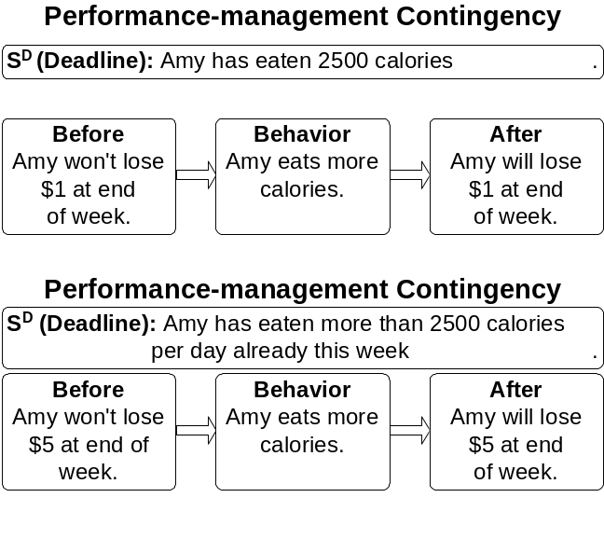

Both of these contingencies are analogs to penalty contingencies, designed to decrease the frequency of behavior, continuing to eat past her 2,500 calorie limit.
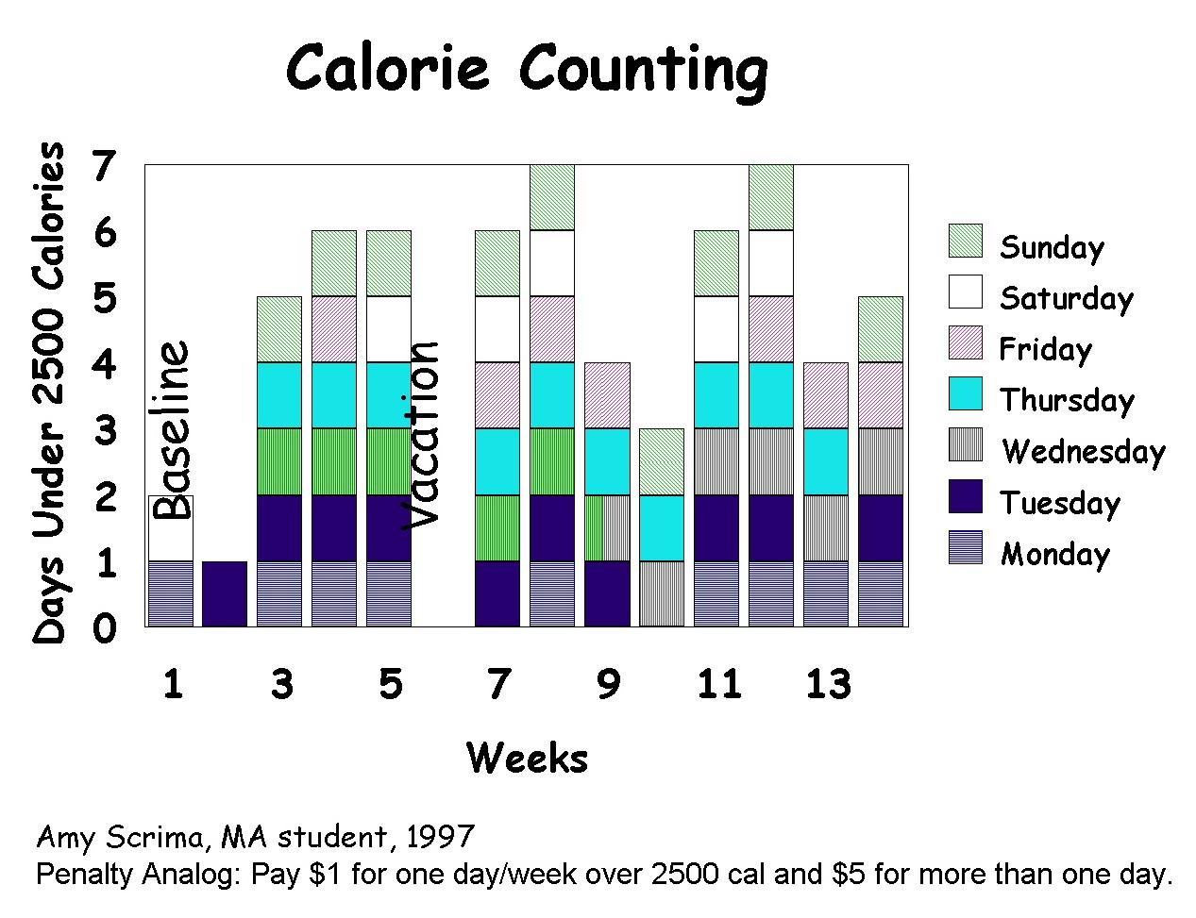

Amy’s performance-management contingencies seemed to work pretty well though it’s a little hard to tell what the $5 penalty contingency added, because she did blow her calories more than once on three different weeks. On the other hand, the extra $5 may have helped her hold it down to only once during two other weeks. In any case, the contingencies seemed to help her do much better than during baseline. Not bad.



Case Study: Andrea’s Omega-3’s
Andrea Juarez, MA Student, 2003

Andrea wanted to get more Omega-3 fatty acids in her diet. She contracted to eat one serving of salmon, walnuts, tuna or fish oil pills five days a week. Here are her contingencies:
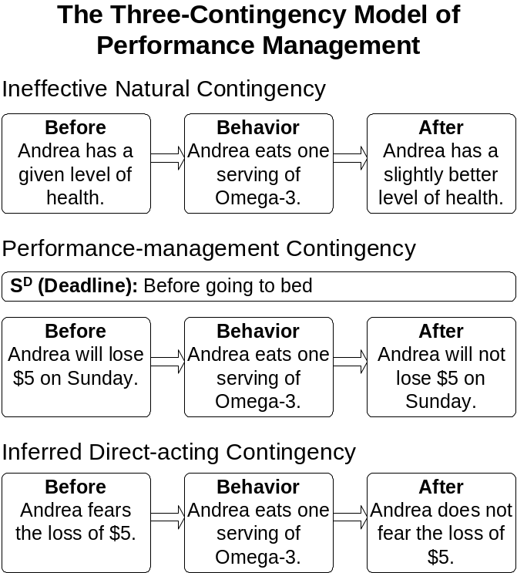
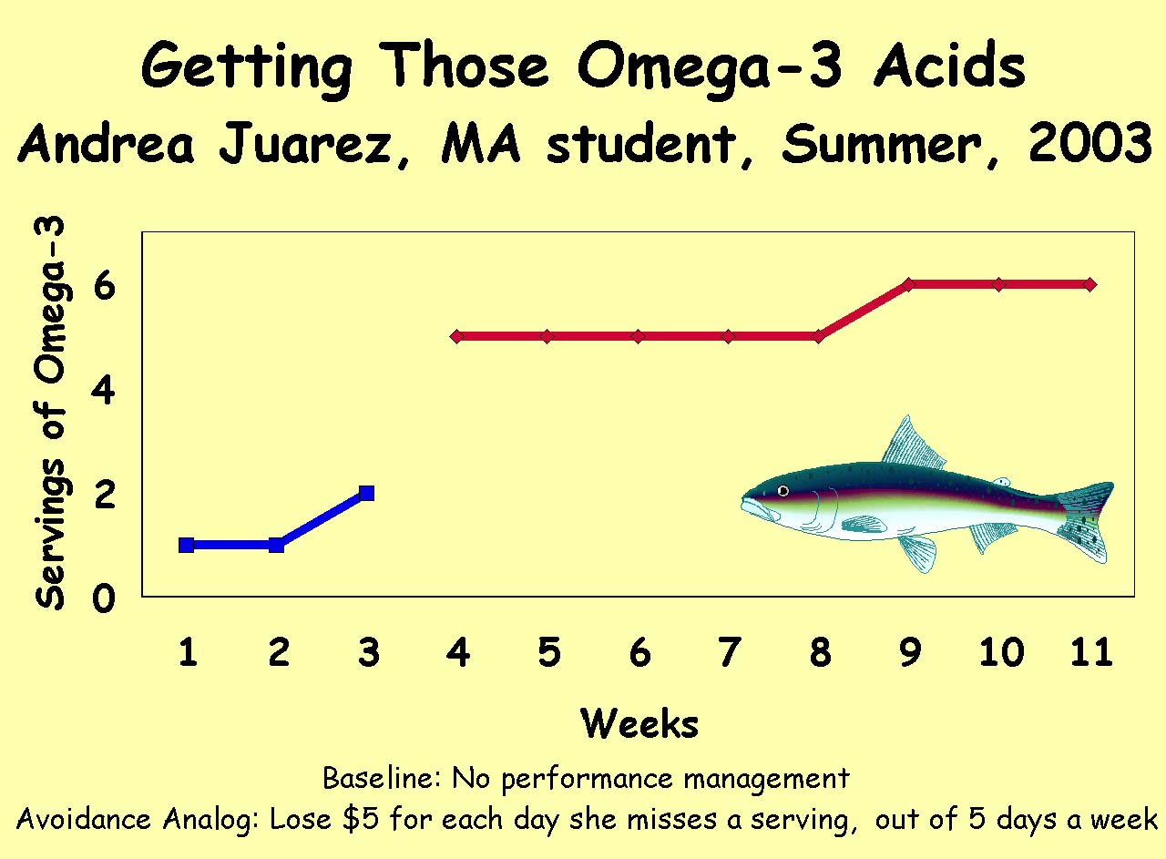

Andrea met her goal for five weeks and exceeded it for three weeks. She didn’t have to pay any money. She says she notices that her skin looks better when she gets enough Omega-3’s. The project was a success and she would like to continue it next semester.


Case Study: Weight Loss/Weight Gain Follow-up Report
Joyce Rogers, BA Student, 1994

I wanted to lose a lot of weight, so I used an analog to a penalty contingency: If I ate more than my allotted 1400 calories, I owed my performance manager $5 for that day.

Baseline was way the hell too many calories to have counted. During performance management, I pretty much stuck to 1400 or less with the occasional binge. I maintained this for the 1.5 years I was in BATS. I also maintained an exercise regimen during that time. And I lost 40 lbs.

Now, I regret having to admit this; but ever since the performance-management contingencies fell away, I’ve been off the wagon and have gained back what I lost plus another 30 lbs. The reason I did away with the PM contingencies is that I got lazy and didn’t want to bother with the reporting and monitoring of my own behavior and now I’m paying the price.

I plan on getting my act together in a few months, when my schedule clears up so I can have time to exercise.

My advice to neophyte procrastinators is: Get on the band wagon and don’t get off ‘cause it’s hell getting back on.

Uncle Dickie Replies

Joyce: As for falling off the wagon, that’s standard. Remember, I spend most of my life struggling to get back on the wagon and then plodding back up comeback road.

In fact, there are some interesting data. Only a small percentage (and small absolute number) of obese people ever succeed in permanently losing their excess weight. But those who do succeed have failed and started again many times; essentially none succeed the first time, or perhaps anywhere near it. They just kept trying, until things finally fell into place. They all integrated weight loss and then weight-control maintenance as a major issue into their daily lives. Also, they all both exercised and controlled their food intake, as I recall.

So I think you have nothing to be ashamed of. Instead, I think you should be extremely proud of your accomplishment. You’ve had a very successful first round and are now getting ready for the second round. That’s great.

I think your case study is very important and inspirational.
Vitality shows in not only the ability to persist but the ability to start over.—F. Scott Fitzgerald (1896–1940)

Why just white males? I don’t know, maybe because, in 1920, more or less the only people doing this research were white males and more or less the only people they gave a damned about were white males. Fortunately times have changed since then, at least a little bit.
“Aging,” Microsoft® Encarta Encyclopedia 99. 1993-1998 Microsoft Corporation.
Editors of the University of California, Berkeley Wellness Letter. The wellness encyclopedia: The comprehensive family resource for safeguarding health and preventing illness. Boston: Houghton Mifflin (page 29).
The Encarta 99 New World Timeline © Copyright 1998, Helicon Publishing Ltd.
Incidentally, I learned this Castro style of surviving a convention from my friend Jack Michael.
For the technically inclined: In the previous contingency diagrams, we’ve been concerned with increasing the frequency of behavior; here we want to decrease the frequency. So, this time the performance-management contingency is like a direct-acting penalty contingency, in that the behavior, eating a Twinkie, will be less frequent because of the contingent loss of the $1. But this performance-management contingency is really a rule-governed analog to a penalty contingency, because the loss would usually occur too long after eating the Twinkie for it to directly punish the eating of that Twinkie. However, the fear of the loss, immediately after eating the Twinkie, would be a direct-acting, punishment contingency.
Remember: Much of the nonpsychological material is grayed. If you find it irrelevant to this course and your interests, just skip the grayed parts. Many students find this stuff great, but it bugs some; and I don’t want you bugged. It’s just info. I’ve found interesting and useful in my perpetual search for rules to help me lead the good life. I include it, in case you find it similarly useful. But one of the problems is that it often implies that your life style is screwed and you should give up many of your most cherished reinforcers, a message no one is eager to read. So you can always skip it, if you can’t take a little spiritual bullying.
Update. Now days, I usually have no trouble keeping candy, ice cream and other foods of the devil around my house. I can still abstain. But sometimes, those foods still sneak up from behind and bite me on the rear end. When that happens, I have to exorcise my home of those devilish temptations, if I haven’t already eaten them all.

